ONLINE EXAMINATION SYSTEM

Project Description: An automated online system for conducting examinations and storing results.

**Submitted by**: P.Uma Bharathi

Roll number:2271112

University:sriPadmavatimahilavisvavidyalayam

Date:08/03/2025

**Table of Contents**

1. **Introduction**
2. **Objective**
3. **System Architecture**
4. **Database Design**
5. **Features**
6. **Code Walkthrough**
7. **Testing**
8. **Conclusion**
9. **Future Scope**
10. **References**

**Abstract**

**The Online Examination System is a web-based application designed to facilitate the examination process in an automated manner. It allows students to log in, take exams, and view their results instantly. The system is developed using Java and MySQL and provides an efficient and user-friendly platform for conducting exams online. This project ensures secure authentication and maintains records of students' performances.**

**Introduction**

**With the growing demand for digital solutions in education, an Online Examination System eliminates the need for traditional paper-based exams. It provides a seamless interface for students to log in, take exams, and receive instant feedback on their performance. The system supports secure authentication and ensures accurate record-keeping.**

**System Requirements**

**Hardware Requirements**

* **Processor: Intel Core i3 or higher**
* **RAM: 4GB or more**
* **Storage: Minimum 500MB free space**
* **Internet Connection: Required for database access**

**Software Requirements**

* **Operating System: Windows / Linux / macOS**
* **Programming Language: Java**
* **Database: MySQL**
* **IDE: Notepad++ / IntelliJ IDEA / Eclipse**
* **GitHub for Version Control**

**Objective**

**Outline the objectives of the project.**

* **To create a system that allows candidates to take exams online.**
* **To automate the process of grading and result management.**
* **To provide a secure login system for users (administrators and candidates).**
* **To store user and exam data in a MySQL database.**

**5. System Architecture**

* **Client-side: The front-end is a command-line interface (CLI) where users (admin and candidates) interact with the system.**
* **Server-side: The back-end consists of Java classes for handling business logic, database interactions, and result calculations.**
* **Database: The MySQL database stores user information, questions, and results**
* **6. Database Design**

**The project uses a MySQL database to store user information, questions, answers, and results. Below is the structure of the tables:**

**• Users Table:**

|  |  |  |
| --- | --- | --- |
| **COLUMN** | **TYPE** | **DESCRIPTION** |
| **User-id** | **INT** | **Primary Key** |
| **username** | **VARCHAR(255)** | **Unique Username** |
| **password** | **VARCHAR(255)** | **User Password** |
| **role** | **VARCHAR(255)** | **User role (admin,user)** |

|  |  |  |
| --- | --- | --- |
| **Column** | **Type** | **Description** |
| **Question-id** | **INT** | **Primary** |
| **Question-text** | **TEXT** | **The Question text** |
| **Option_a** | **VARCHAR(255)** | **Option A** |
| **Option_b** | **VARCHAR(255)** | **Option B** |
| **Option_c** | **VARCHAR(255)** | **Option C** |
| **Option_d** | **VARCHAR(255)** | **Option D** |
| **Correct_option** | **CHAR(1)** | **Correct Answer(A,B,C,D)** |

**Results Table:**

**Project Features**

|  |  |  |
| --- | --- | --- |
| **Column** | **Type** | **Description** |
| **result_id** | **INT** | **Primary Key** |
| **user_id** | **INT** | **Foreign Key from Users** |
| **Score** | **INT** | **Total Score** |
| **exam_date** | **TIMESTAMP** | |  | | --- | | **Date and Time of Exam** | |

* **User Authentication – Secure login system**
* **Take Exam – Users can attempt exams**
* **View Results – Users can see their performance instantly**
* **Database Management – Store user details and exam scores in MySQL**
* **Admin Panel (Future Scope) – Manage users and exams**

**Database Design**

**Tables Used**

* **users (stores user credentials)**
* **exams (stores exam questions)**
* **results (stores scores and timestamps)**

**Implementation**

**The system is implemented in Java with MySQL integration. The key modules are**

1. **UserLogin.java** – Handles authentication
2. **TakeExam.java** – Displays questions and evaluates answers
3. **ViewResults.java** – Fetches and displays user scores from MySQL
4. **DBConnection.java** – Manages database connections

Testing

* **Unit Testing**: Each component of the system was tested independently, such as the login system, question fetching, and score calculation.
* **Integration Testing**: The system was tested as a whole to ensure that the database, back-end logic, and user interface were working together correctly.
* **User Acceptance Testing**: Final testing was done by end-users to confirm the system meets the requirements.

**Screenshots & Outputs**

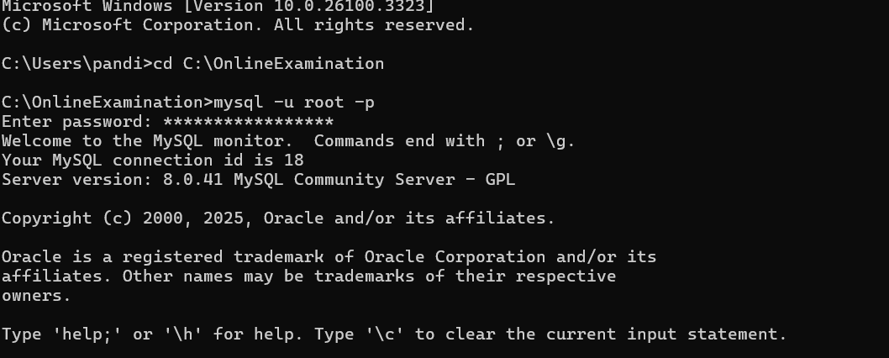

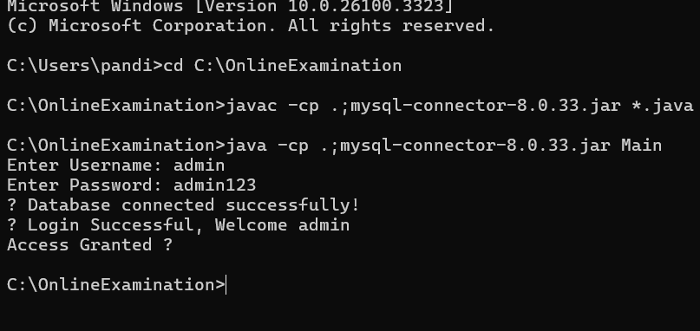

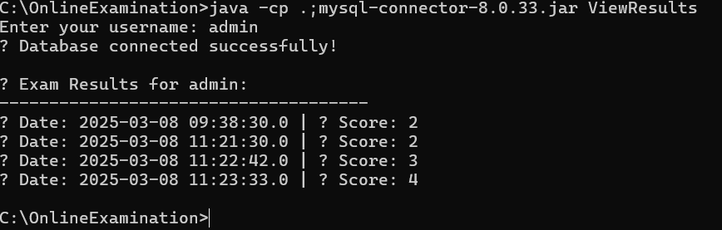

**Conclusion**

**The Online Examination System is an efficient and user-friendly platform that automates the examination process. It provides a seamless experience for both candidates and administrators and meets the requirements of modern examination systems. The project was successful in implementing the core features of exam-taking, scoring, and result management.**

**11. Future Scope**

* Adding support for multiple choice, true/false, or essay-type questions.
* Implementing an online timer for exams.
* Developing a web-based version of the system for broader accessibility.
* Enhancing security features such as two-factor authentication.

**References**

GitHub Repository: <https://github.com/PandiUmaBharathi/OnlineExaminationSystem>